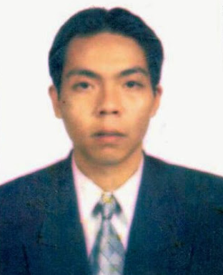

CURICULUM VITAE

Personal Data

Name : TRIHITO ERIBOWO S.E
Place and Date of Birth : Jakarta , August -4th- 1979
Gender : Male
Religion : Islam
Nationality : Indonesian
Proficiency in Languages : Fluent in Indonesian and English
Marital Status : Single
Health : Good
Photograph : Enclosed
Phone number : 081281223643 / 021-96006197

Education

Graduated from Sahid University majoring in Hotel Management.

Organizational Experience

1997—till now : Member of UMUS ( unit music universitas sahid )
1993—2001 : Karang Taruna

Trainings and Other Education
1993—1996 : English course at oxford at intermediate level
2002 : Computer course Ms-office 2000 at LM-PATRA

Working Experiences

2002 : Three months on the job’s training at sahid jaya hotel yogya
2003-2004 : Work at Maharadja hotel as F.O crew
2005 : Work at Bank Mandiri as sales executive consumer loans
2005- 2007 : Work at pt Exelcomindo as Channel Support and call center agent’s
2008 : Work as Call Center agent for Indonesia Air Asia
2009-2010 : Work as Foreign Telemarketing at PT. Samudera Primula Mandiri
2010-2015 : Work as Customer Service, HRD and Public Relationat Staff at PT Kreon

Special Interests

Writing Article at my blog at Kompasiana: http://www.kompasiana.com/trihito. Foot Ball Columnist for Top Skor Sport Newspaper

